Electric Vehicle Charing Infrastructure Gaps Across the United States
ECSN 460 – Stage 2: Visualization
Sawyer Bringle & Liam Maumenee

Overview:
Electric vehicle adoption has grown rapidly across the United States, and this growth has raised concerns about the adequacy of charging infrastructure. The distribution of EV charging stations varies widely: some regions have dense networks of chargers, while others remain significantly underserved. Understanding where these gaps exist, and what demographic or geographic factors predict them, is critical for policymakers and private companies deciding where to invest in new charging infrastructure.

Our project examines EV charging infrastructure gaps across three states – Colorado, Connecticut, and Washington – by comparing county-level EV adoption with the availability of public charging stations. We combine this with demographic data to explore whether income or racial composition are associated with charging access.

Data Sources:
We use four publicly available datasets from three sources:

EV Registration Data: The three states’ data arrived in different formats. Colorado was already aggregated to the county level, so it was easy to clean. Connecticut and Washington provided individual vehicle records that we aggregated to the county level by counting registrations per county. Connecticut presented a unique challenge: the data records each vehicles’ town of registration, but Connecticut uses 169 towns rather than counties. We built a crosswalk mapping each town to one of Connecticut’s 8 historical counties, which allowed us to aggregate to a comparable geographic level.

Charging Stations AFDC: We filtered the national AFDC dataset to include only electric vehicle stations in our three states with an “open” status. We then performed a spatial join using the sf package in R, matching each station’s latitude and longitude coordinates to U.S Census County shapefiles to assign every station to a county. This allowed us to count the number of stations and charging ports per county. A complication arose in Connecticut, where the Census Bureau replaced counties with “Planning Regions” in 2022. We addressed this by mapping the planning region names back to historical county names used in the EV registration data.
ACS Demographics: The ACS data was downloaded in a wide format, with counties as columns and variables as rows. We reshaped this to a long format and extracted total population, median household income, median age, and racial/ethnic population counts for each county. For Connecticut, we again had to map the planning regions to historical counties.

Final Dataset: We joined the EV registration counts, station counts, and census demographics into a single master dataset at the county level. We then calculated several derived metrics: EVs per charging station, EVs per 1,000 residents, stations per 100,000 residents, and percent nonwhite population.

Visualizations

Figure 1: Top 10 Counties by EV Registrations

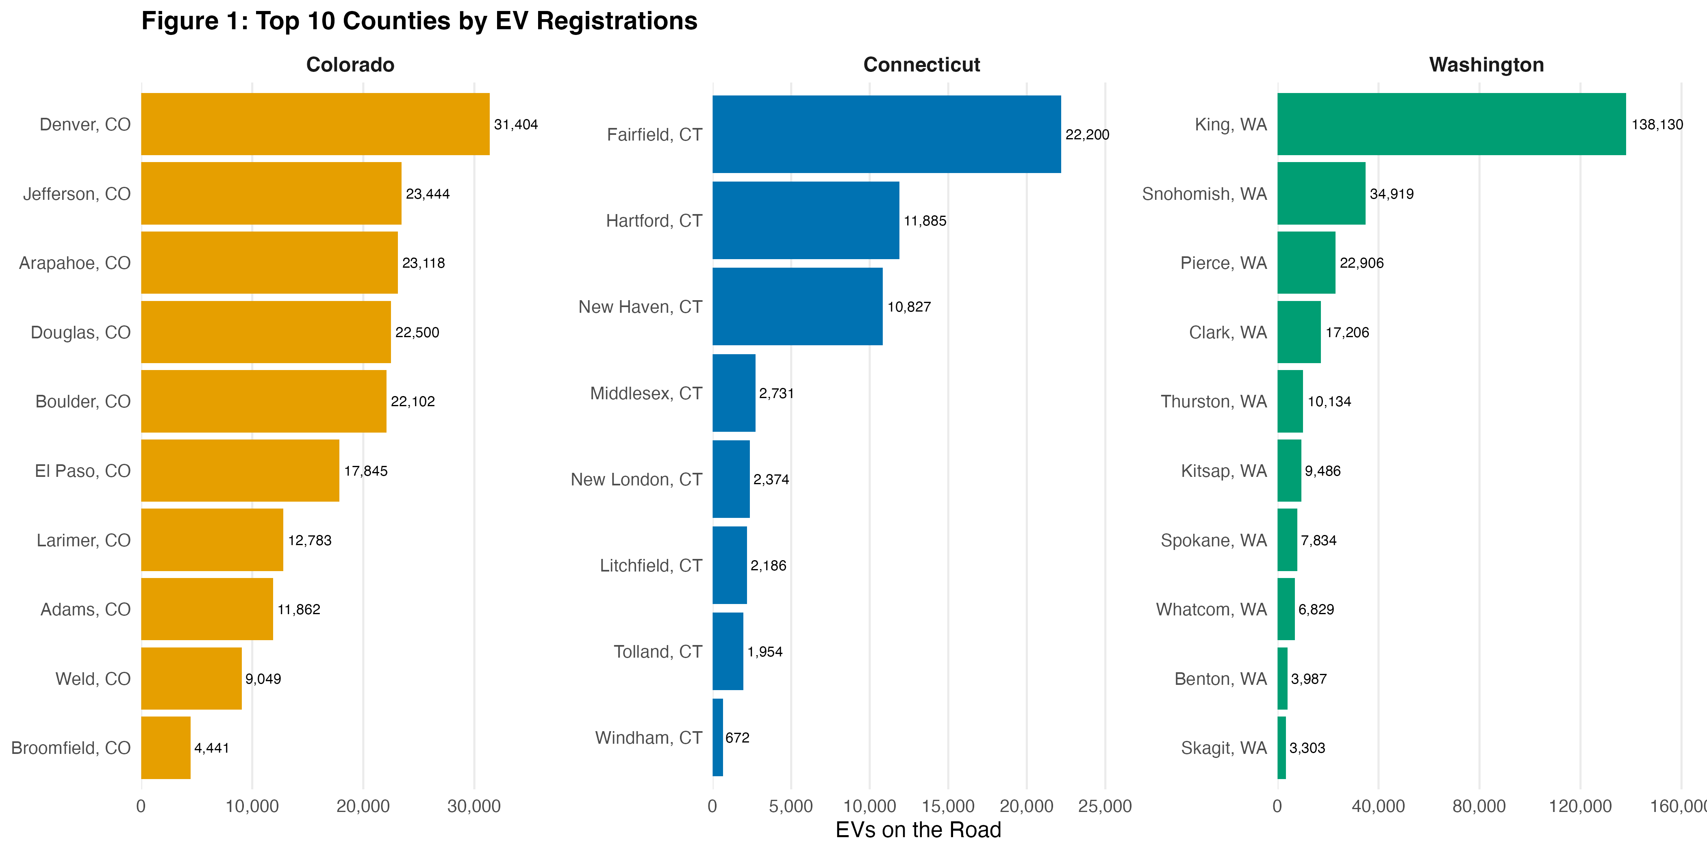

This figure provides a baseline context as to where the majority of EVs are located in each state. We chose a horizontal bar chart so that each state can be compared on its own scale. This figure shows that EVs are heavily concentrated in certain urban areas across these states. This figure is important for infrastructure analysis as it is showing where EVs are located and the types of counties they are located in.

Figure 2: Median Household Income vs. EV Adoption Rate
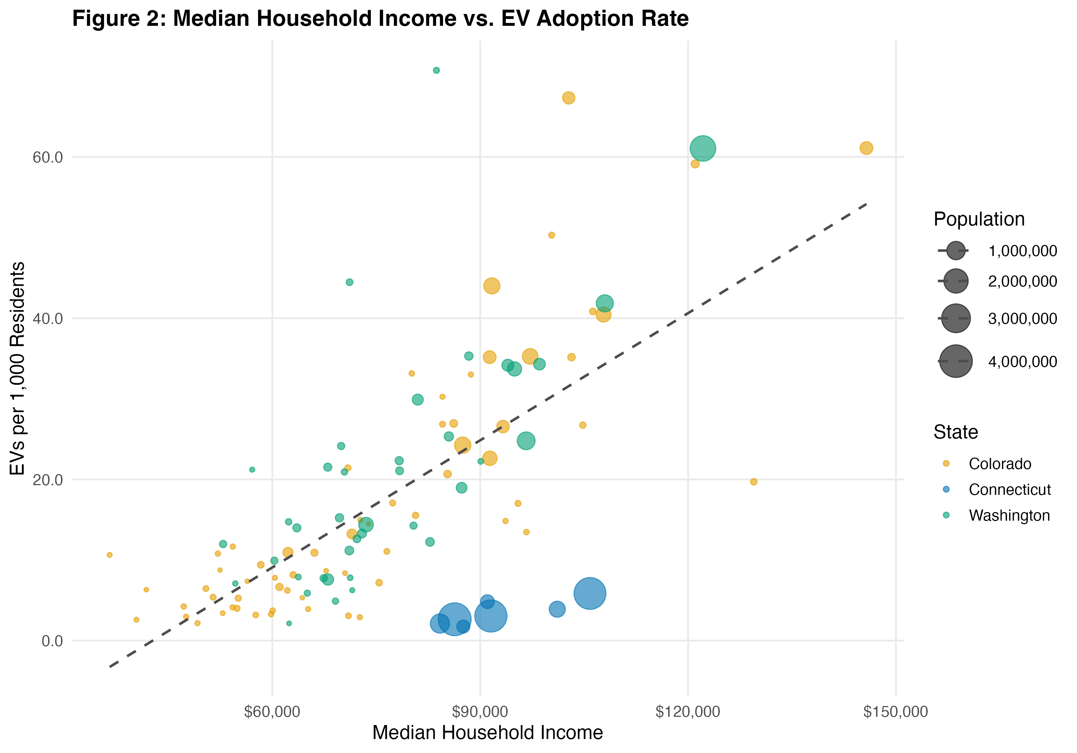
This scatter plot explores weather wealthier counties have a higher concentration of EVs. Each point on this plot represents a county, with the point size scaled to the population of the county. The dashed line shows that there is a strong correlation between income an EV adoption with some outliers within the data.

Figure 3: Charging Stations vs. EVs on the Road
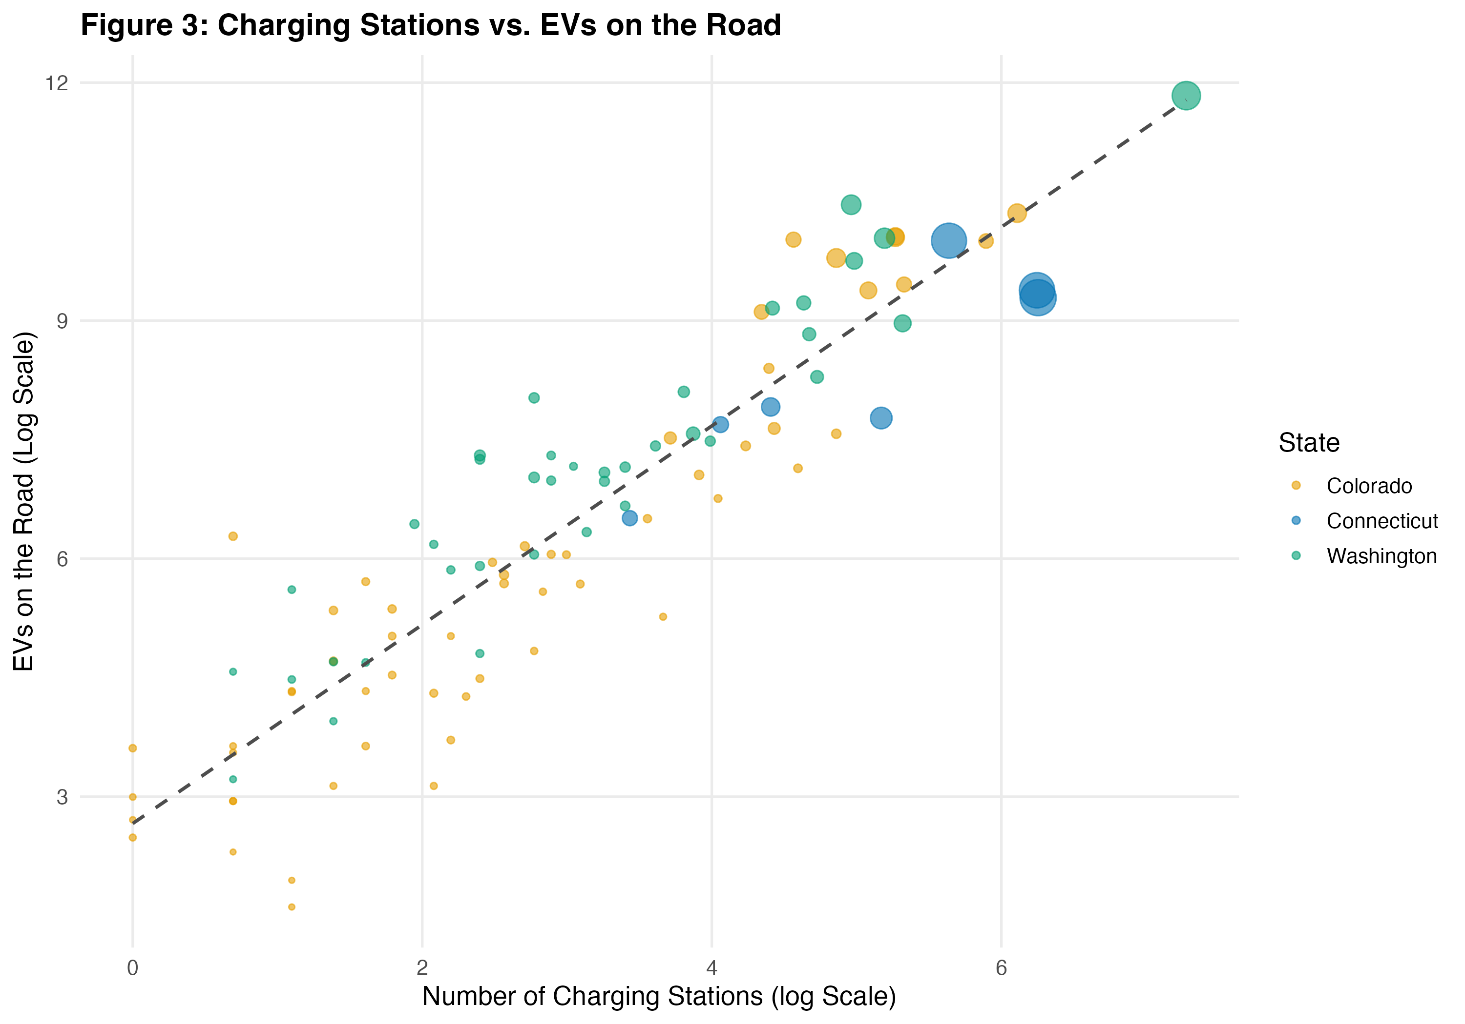
This is a very important figure as it is getting at our key question of where does infrastructure lag EV adoption. In this scatter plot we are looking at the number of charging stations vs the number of EVs on the road by county. As you can see from this graph these two variables seem to be highly positively correlated. The log scale was necessary as both variables span several orders of magnitude, from rural counties with very few EVs to heavily populated counties with many EVs.

Figure 4: Percent Nonwhite Population vs. Charging Access

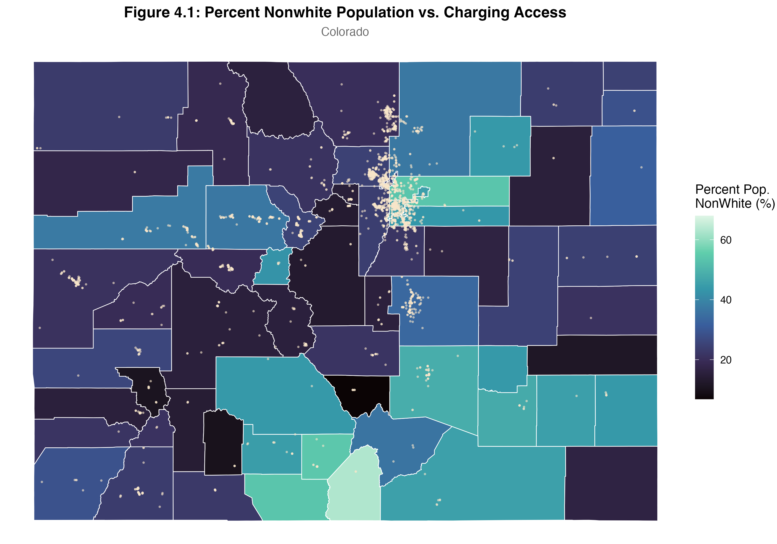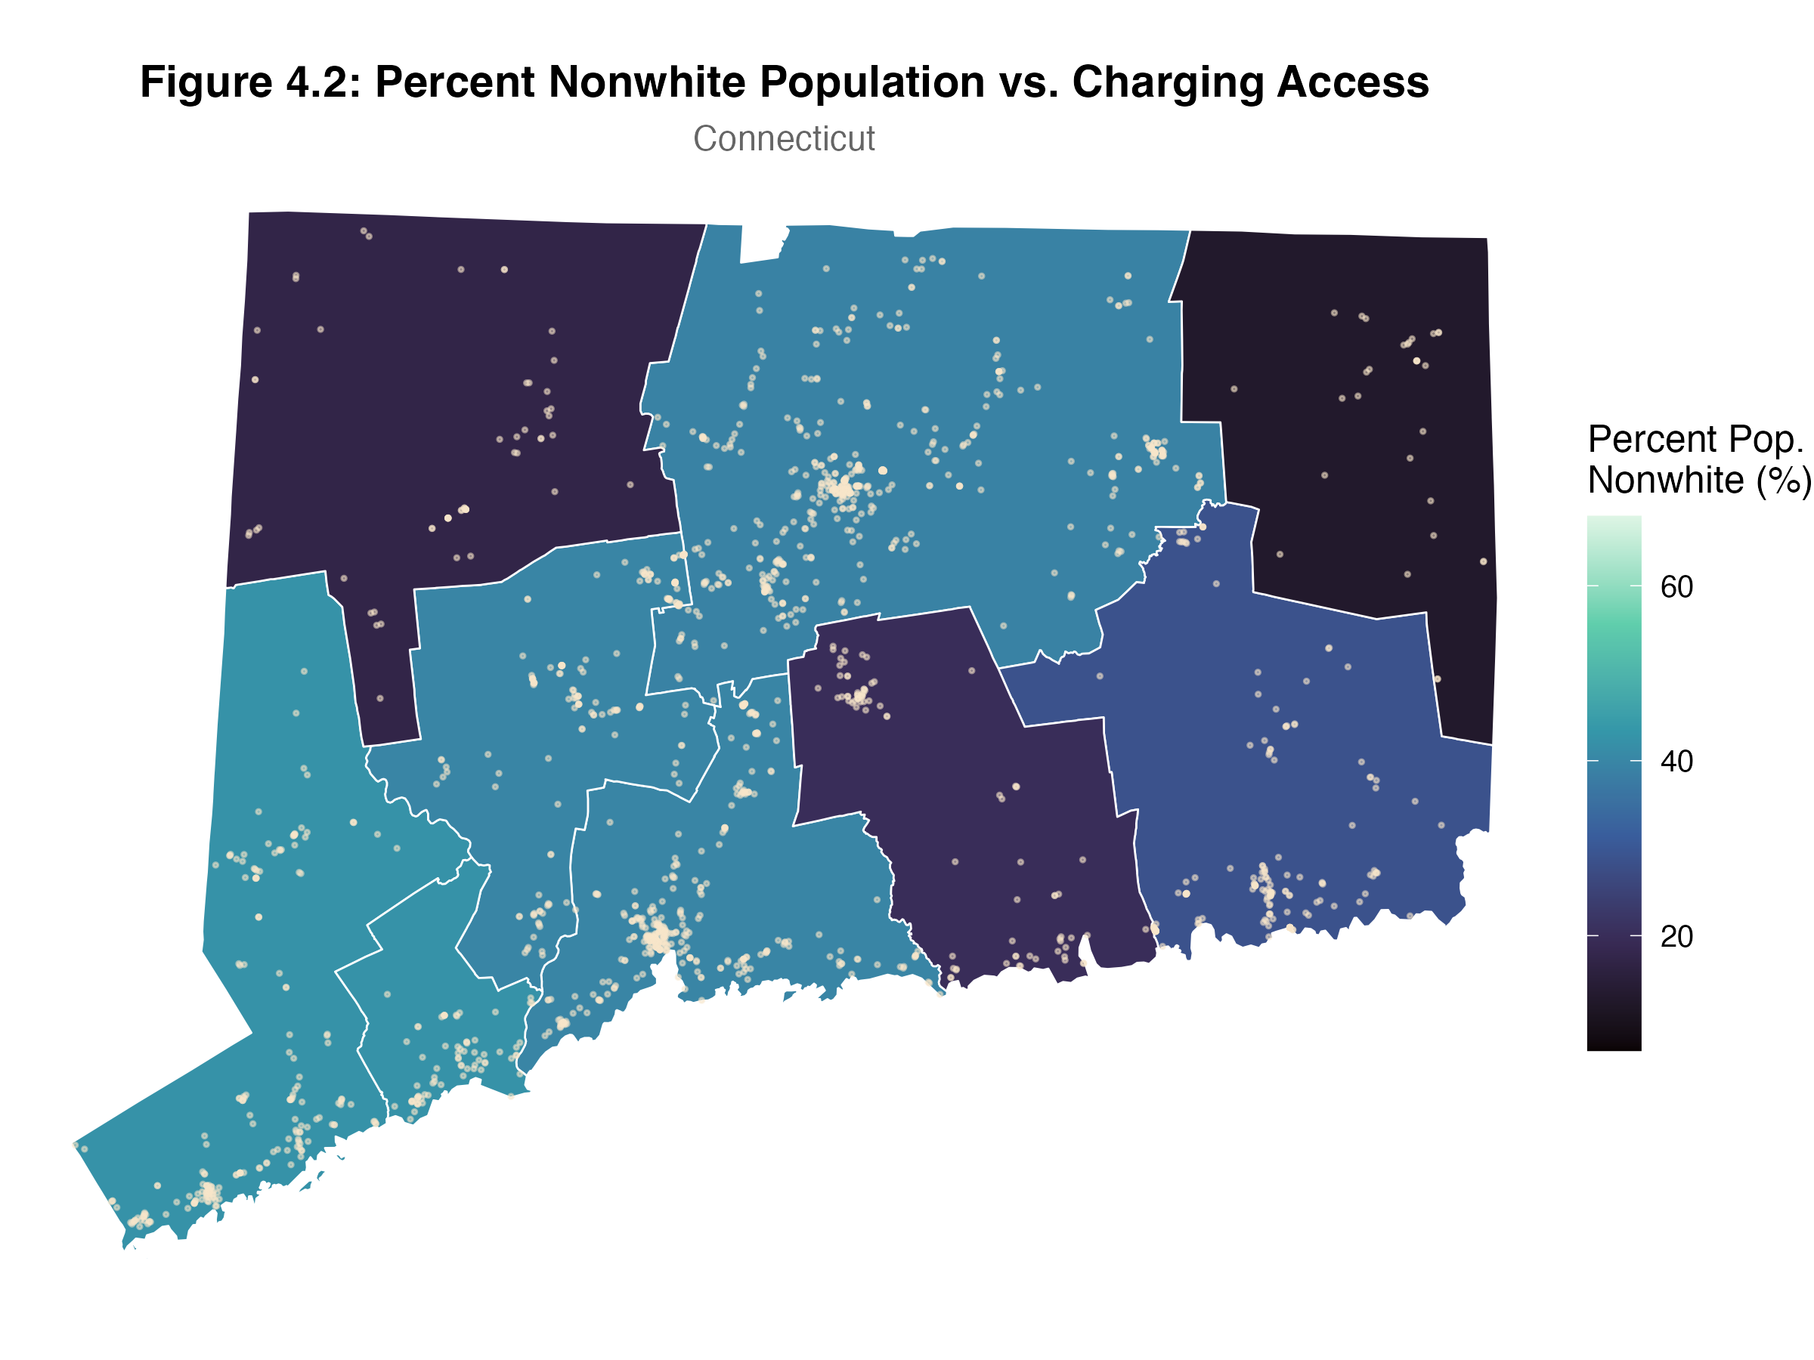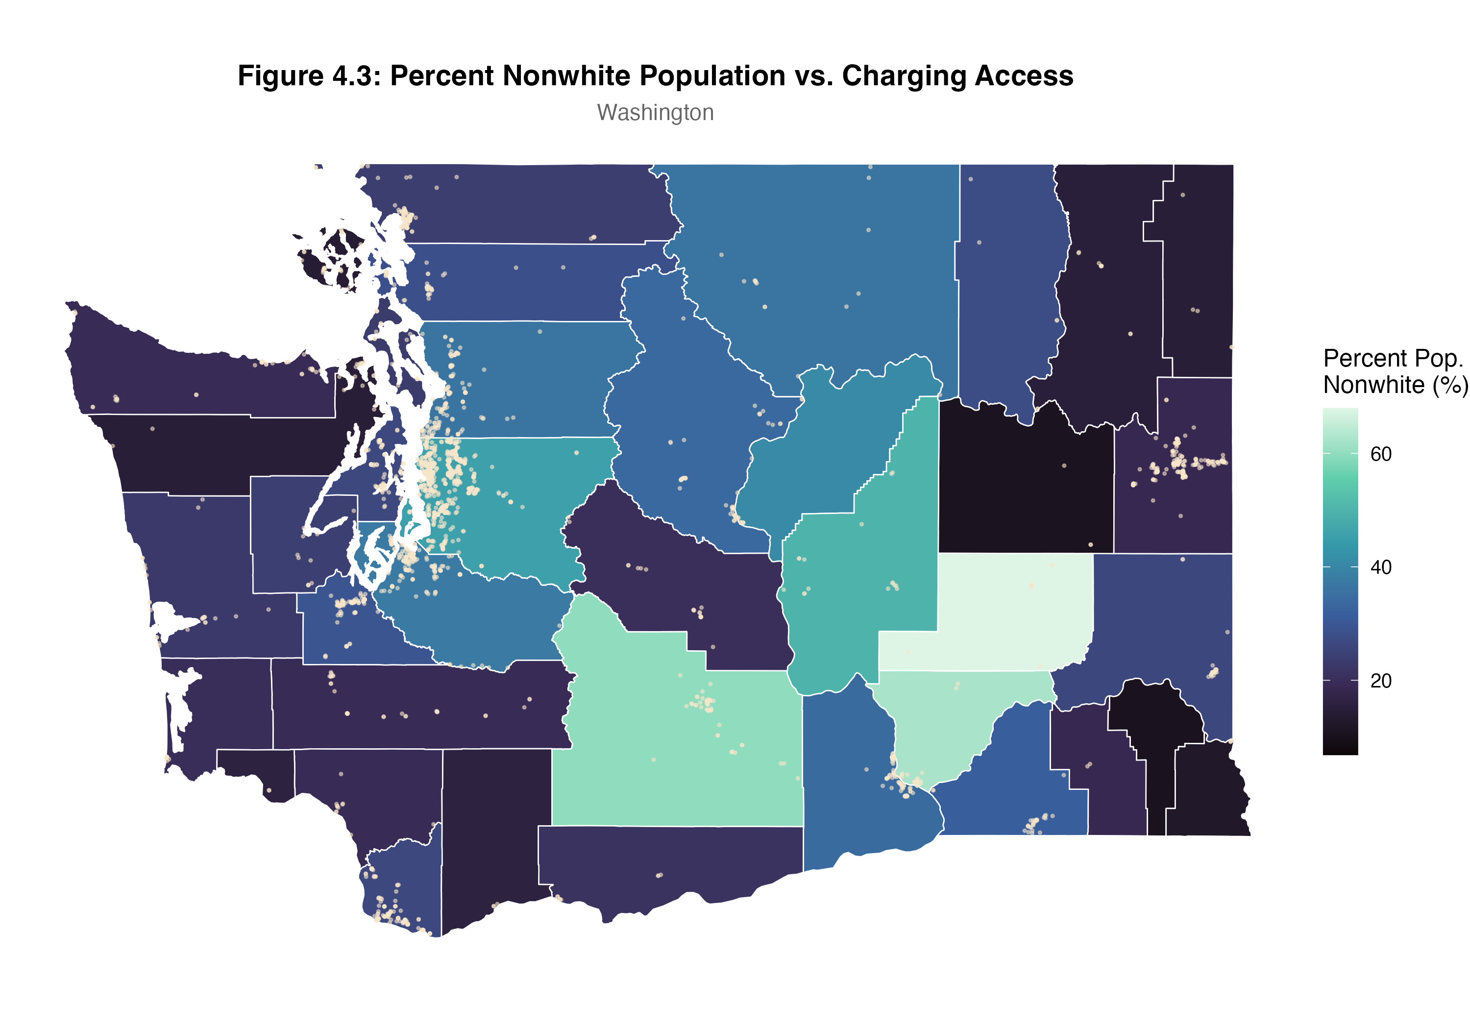

This figure is important to our project as one of our final deliverables we hope to create is an interactive shiny web app with all the EV stations across these three states. These visualizations are showing all the EV charging stations that are currently operating as dots across the three states. We also overlayed a choropleth showing the percent nonwhite population percentage in each of these counties as we thought this may be an interesting relationship to look at for later economic analysis. Overlaying this variable can help to identify which variables can be used in a predictive model.

Figure 5: Top 15 Charging Desert Counties
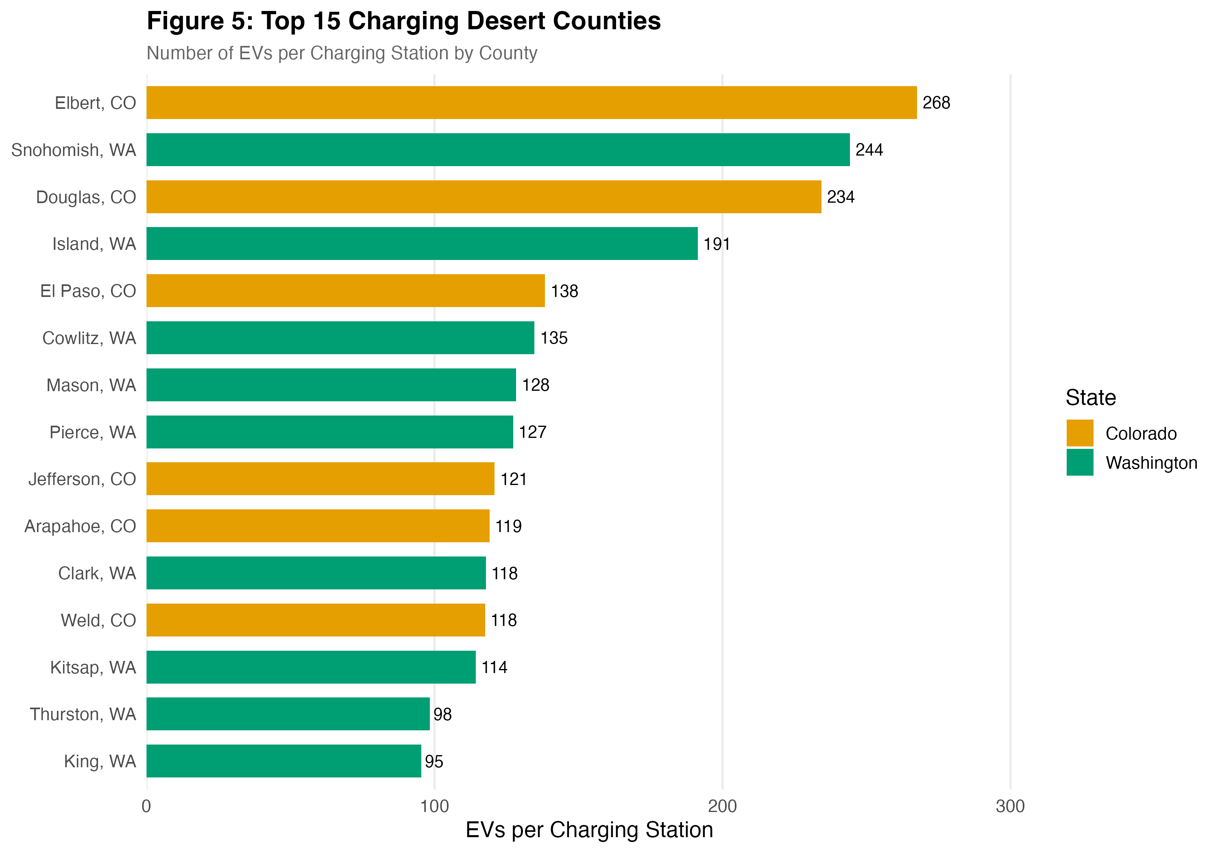
This figure is very important for our economic analysis as we are looking at the top 15 charging deserts or states with the most EVs per charging station. Took look at this relationship we removed counties with less than 50 EVs on the road and counties with less than 1 station. This figure is helpful as it is showing were to build charging infrastructure next.

